Herbs & Flowers information sheet

How to care for your plants
Keep them covered with polythene (coriander and oregano don’t need covering). Once you start to see a shoot of green, take the polythene off.
Store your seeds in a warm place
1) at around 16-18C for coriander and oregano
2) at around 24 Celsius (75F) for other herbs.
Keep them in a warm light position and don’t overwater them. As the plants get bigger, you can transfer them to a larger pot.

Chives
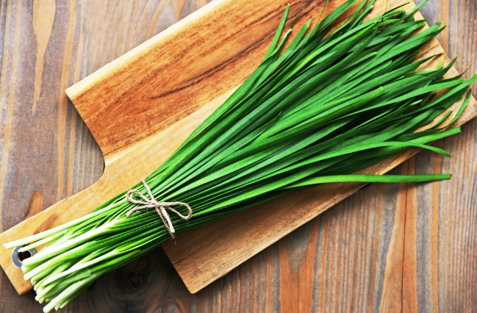
Health benefits
Chives contain Choline and folate, individually each of these components are linked to improving memory functions. It also contains compounds which help to deter cancer from growing in the body.

Cooking tips
Chives have a pungent flavour, between garlic and onion. They go best as a garnish, sprinkled on top of baked potatoes of garlic bread!

Sage
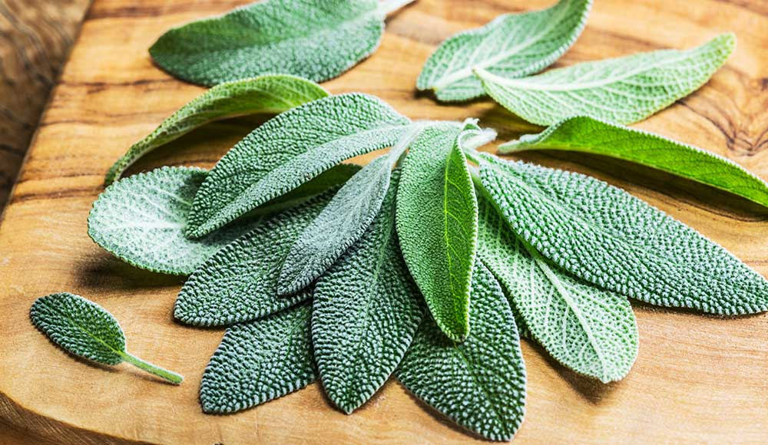
Health benefits
Sage has several types of acidic compounds that act as antioxidants which can help to prevent damage to cells. It also has been shown to have an antimicrobial effect, aiding in killing plague.

Cooking tips
Sage has an aromatic flavour and is often used when making tomato sauces, but can also be used when making teas, or as a rub for meats.

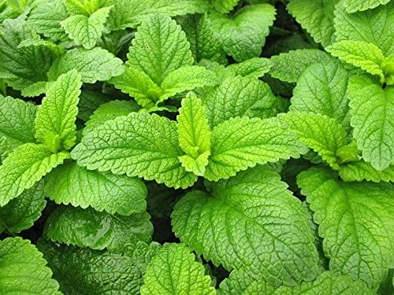
Lemon Balm
Health benefits
Lemon balm has been shown to reduce anxiety and relieve stress as well as helping to improve sleep. Compounds in lemon balm have also shown to help relieve and ease digestive problems such as bloating or indigestion.

Cooking tips
Lemon balm can act as a substitute for lemon peel in dishes like sauces and soups or can be used to make a vinaigrette when added to olive oil and vinegar.

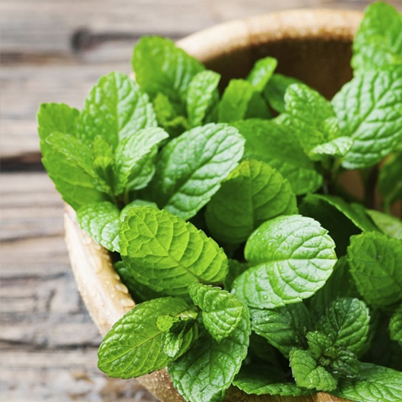
Peppermint
Health benefits
Peppermint has compounds that can east the gastrointestinal tract, easing symptoms of IBS and other stomach pains. The active ingredient in peppermint can also lessen the pain of migraines and tension headaches.

Cooking tips
Some classic pairings for peppermint are mixing it with fresh peas, or with lamb. But you can add it to all veggies to create minted vegetables.

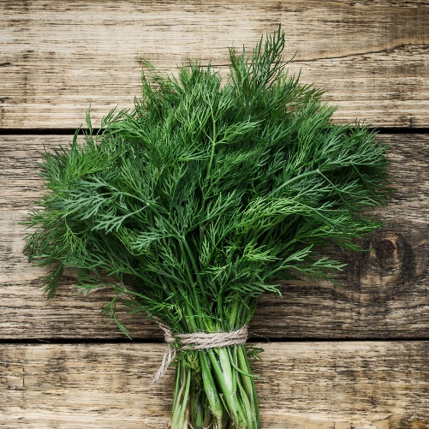
Dill
Health benefits
Dill has been shown to reduce the risk of heart disease and research has shown it can reduce cholesterol. It also is a great source of vitamin A, C, Calcium, and Iron.

Cooking tips
Dill is used in tzatziki along with Greek yoghurt, cucumber, lemon, and garlic. You could also use it when making roasted carrots, or as a garnish for salmon!

Parsley
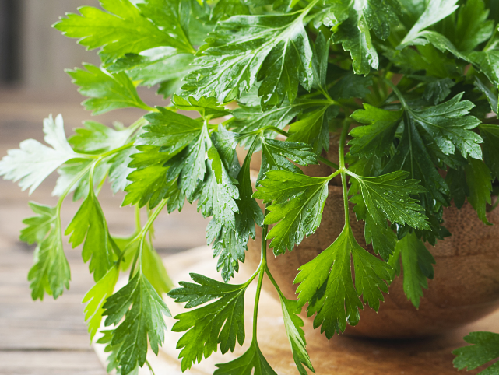
Health benefits
Parsley is loaded with vitamin K which is linked to bone health, it can support bone growth and bone mineral density. It also contains flavones which have are antioxidants, and research has shown they have some anti-cancer benefits.

Cooking tips
Parsley can be added to soups, often used in a bundle with other herbs in French soups, stocks and sauces. It can also be sprinkled over dishes to add a finishing touch.

Fresh oregano
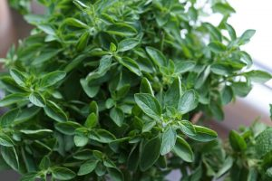
Health benefits
Fresh oregano is a great antibacterial agent. It has nutrients which fight certain viral infections. It’s loaded with antioxidants that help prevent cell damage – and this means it potentially has anti-cancer properties. It’s also full of fibre, iron and calcium.

Cooking tips
Oregano goes with tomato, which is why it often features in pizzas and pasta sauces. Try sprinkling chicken with oregano or add fresh oregano leaves to a salad.

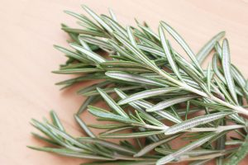
Fresh rosemary
Health benefits
Rosemary can be used to ease muscle pain, as a treatment for indigestion and to promote hair growth. There is also some evidence that the smell of rosemary can improve memory.

Cooking tips
Rosemary is versatile and you can use it in recipes for chicken, lamb and fish, especially oily fish. It also goes well with peas, potatoes, and spinach. For some instance flavour, try making rosemary butter. It’s an excellent topping for steak, or you can use it on baked potatoes or tossed with pasta.

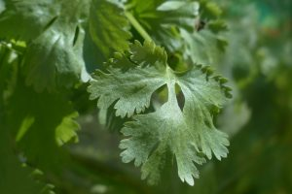
Coriander
Health benefits
Coriander may help lower your blood sugar and bad cholesterol. It has anti-inflammatory properties that can help fight infections and it is good for diseases such as arthritis. There is also beta-carotene in the leaves, which prevents several diseases that affect the eye.

Cooking tips
Coriander is great to add to curries and sauces. It’s a favourite to use to flavour soups, that’s why carrot and coriander is so popular. If you’re feeling a bit more adventurous, use it to flavour homemade bread – you can even try it as an ingredient for some cakes and biscuits including gingerbread.

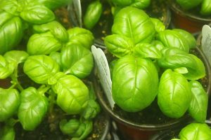
Sweet Basil
Health benefits
Studies suggest sweet basil may reduce memory loss associated with stress and reduce depression related to stress. Prevent certain cancers, including of the breast, colon and pancreas. Having the smell of sweet basil around can also increase mental alertness when inhaled as aromatherapy.

Cooking tips
The favourite way to use basil is to create a pesto sauce — basil’s most popular uses. It’s typically made from crushed basil, garlic, parmesan cheese, olive oil and pine nuts, though dairy-free options are also available. Try it as a dip or sandwich spread.

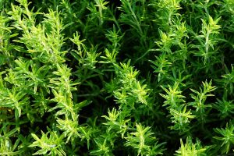
Thyme
Health benefits
The active ingredient in thyme (thymol) can help prevent fungal and viral infections. If you are suffering from asthma, colds, blocked sinuses or seasonal allergies, thyme can also help. It eases inflammation to help you breathe.

Cooking tips
Thyme is the main ingredient in the many herb blends, including the French combination Herbes de Province. It goes well with eggs, tomatoes, and cheese, so it’s an excellent addition to omelettes. Try using it as seasoning for poultry, as well as recipes for stuffing.

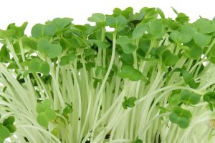
Cress
Health benefits
Fresh garden cress contains much more vitamin C than fresh oranges! Vitamin C is crucial to keeping you skin, bones, and gums strong and healthy. Scientific research suggests that vitamin C may also help keep your cardiovascular system healthy. An ingredient found in cress might also stop acid production in the mouth, helping to reduce dental cavities.

Cooking tips
The leaves and stems can be eaten in salads and used in soups, canapés, and omelettes. Blend with butter to make a tangy spread for sandwiches or go for a classic egg and cress sandwich. The seeds can be made into mustard.

Flower symbolism
Candytuft – Sweetness and beauty
Poppy – Fertility, remembrance, and sacrifice. Peace, hope and resilience.
Cornflower – Hope, Remembrance, devotion, anticipation, wealth, prosperity, and future.
Alyssum – Beauty, protection.
Lobelia – Distinction and malevolence.
Ipomoea – Love and mortality.
Nigella – Harmony and love.
Sunflower – Faithfulness, worship, adoration, and loyalty.
Nasturtium – Victory and success.
Petunia – Anger, resentment, desire, and hope.
Sweet pea – Gratitude and happiness.
Foxglove – Protection and healing.
Echinops – Independence and nobility.
Marigold – Happiness, joy, and grace.
Lavender – Devotion and purity.
Pansy – Innocence, modesty, faith, spirituality, and everlasting love.
Forget me not – Hope, remembrance, and true undying love.

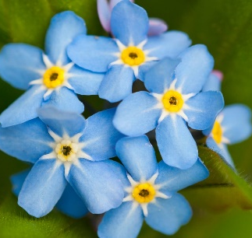
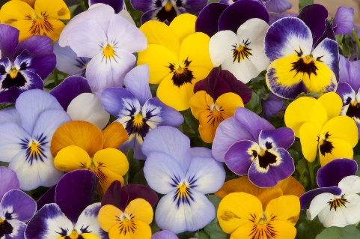
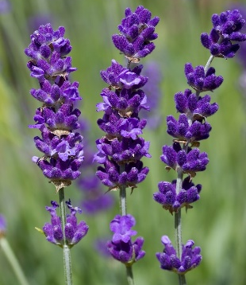
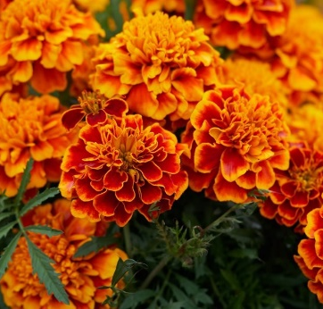
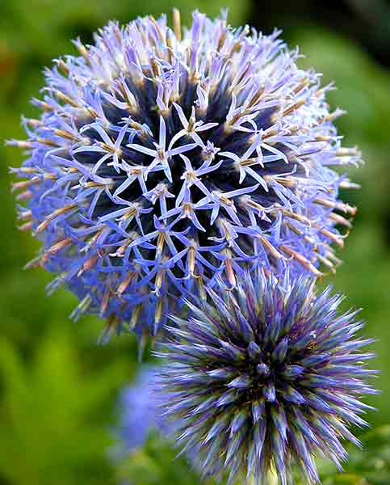
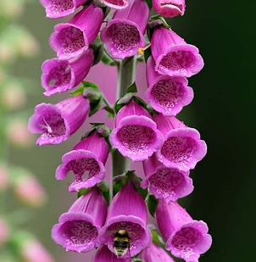
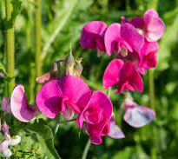
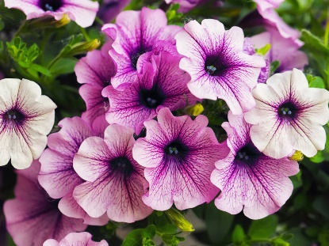
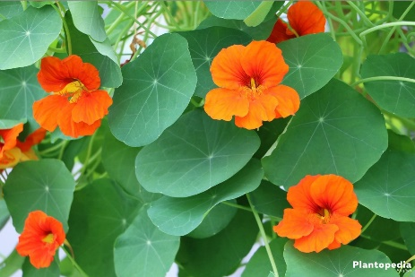
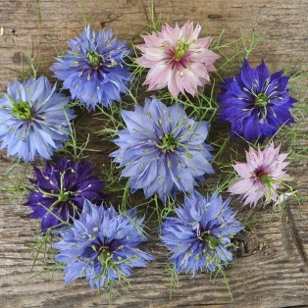
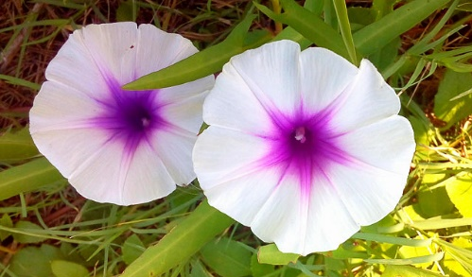
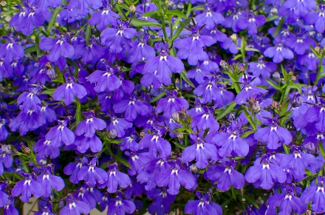
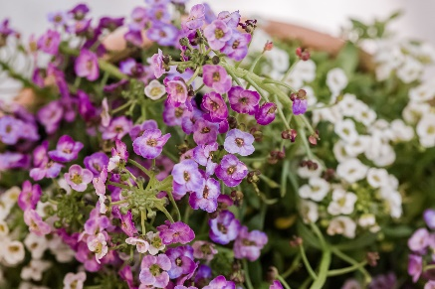
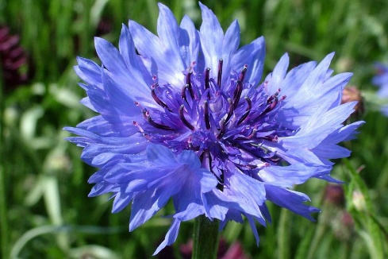
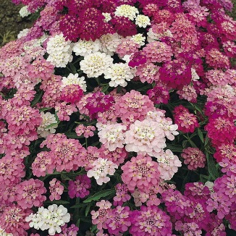
Forget me not
Pansy
Lavender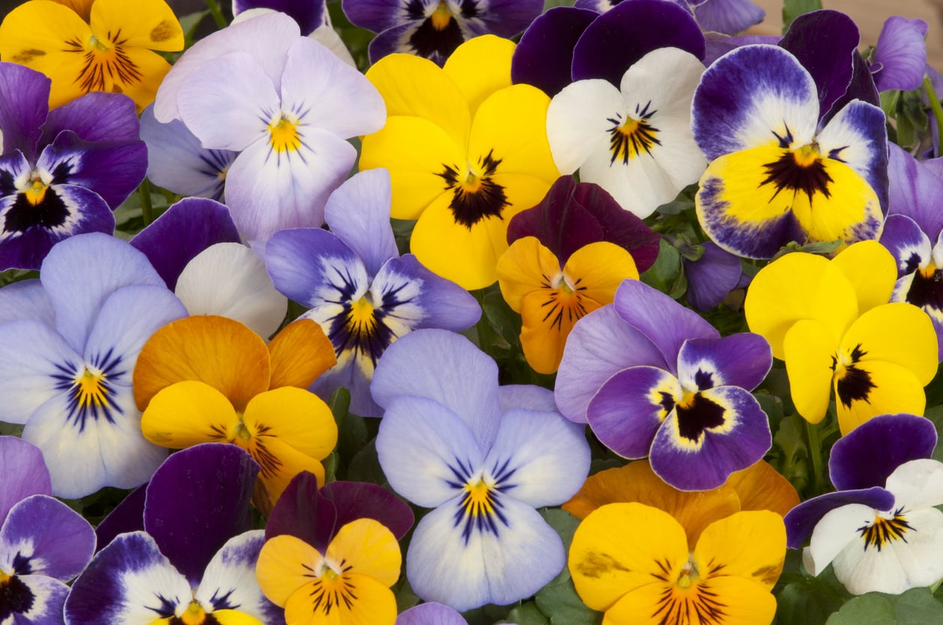
Marigold
Echinops
Foxglove
Sweet Pea
Petunia
Nasturtium
Sunflower
Nigella
Ipomoea
Lobelia
Alyssum
Cornflower
Poppy
Candytuft

